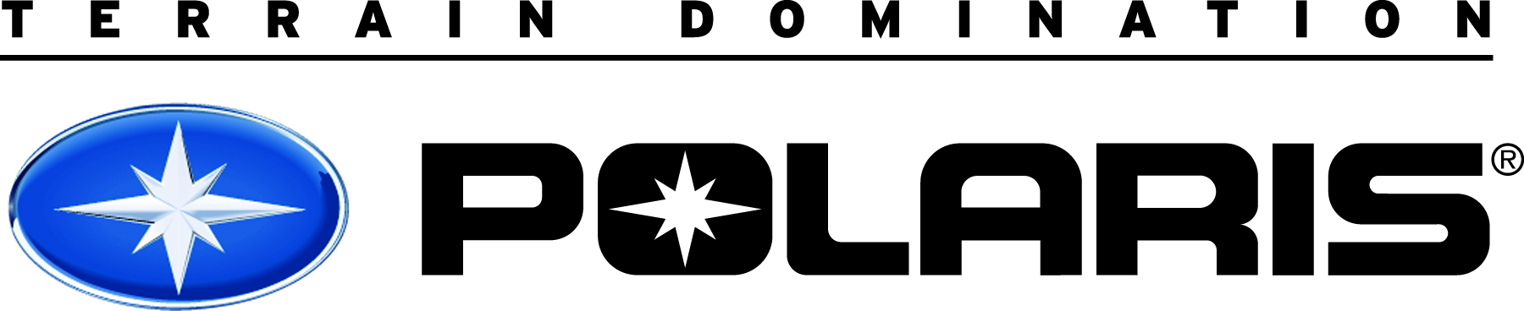
POLARIS 2018/2019 SNOWMOBILE RACING APPLICATION

Due: May 15, 2018 Please Print Clearly!

Today’s Date: ________________ Date of Birth: ____ /_____ /________

First Name: _________________ Middle Initial: _______ Last Name: ______________________

Mailing Address Including P.O. Box: ___________________________________________________________

Street Address: ___________________________________________________________________________

City: _____________________ State/Province: _______ Zip/Postal Code: ________

County (you live in): __________________ Day Phone #: (________)_________-_________

Work Phone #: (________)_________-_________ E-mail Address: _________________________________

Polaris Dealer that you work with, please provide Dealer Name and Phone Number below:

___________________________________________________________ (________)-_________-_________

Have you been on the Polaris Racing program before? YES NO If YES, when? _____________

How many years have you been racing? __________ Years

What class(s) did you race in last season? (Check all that apply)
☐ Pro ☐ Semi Pro–Pro Lite ☐ Sport-Amateur ☐ Womens ☐ Masters ☐ Juniors

Below please list the racing association you will be competing in during the 2018/2019 race season.
Racing Association: ______________________________________________________________________

POLARIS 2018/2019 SNOWMOBILE RACING APPLICATION

Please check the primary venue that you are participating in as well as the snowmobile model you are applying for. In front of selected model please list the number of snowmobiles you want to purchase. Snowmobile model price includes shipping but not sales tax. If you are approved you will be notified by letter stating total cost which will include sales tax. Pricing is listed in U.S. dollars.

☐ SNO-CROSS ___ 600 R ($7,625.00); ☐CROSS-COUNTRY ____ 600 Indy XC ($7,925.00);

☐IRON DOG ____ 600 Indy XC ($7,925.00); ☐OVAL ____ 600 Indy XC ($7,925.00);

☐ HILLCLIMBS ____ 850 Pro RMK 155 ($7,725.00); ☐ENDURO ____ 600 Indy XC ($7,925.00);
____ 600 RMK ($7,325.00); ____ 600 R ($7,625.00)

Please list the top five accomplishments that highlighted your 2017/18 race season:

1.______________________________________ 2. __________________________________________

3. _____________________________________ 4. __________________________________________

5. ______________________________________

APPLICATIONS MUST BE RECEIVED BY MAY 15, 2018 TO THE ADDRESS BELOW:
POLARIS RACING DEPARTMENT
ATTN: RACE APPLICATION
202 INDUSTRIAL PARK AVE
ROTHSCHILD, WI 54474
PHONE: 715-355-5157

FAXED or E-MAILED RACE APPLICATIONS WILL NOT BE ACCEPTED

Thank you,
Polaris Race Department

